**Socket programming**

Socket programming is a means of communicating data between two computers across a network. Connections can be made using either a connection-oriented protocol or a connectionless protocol.

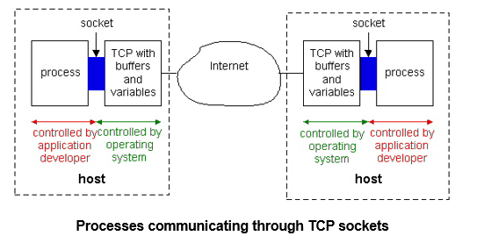

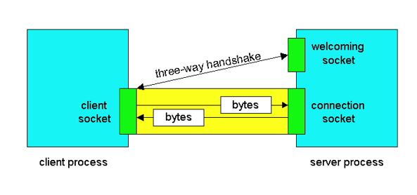

**Example:**

**Calculator Application by using socket programming.**

**Server:**

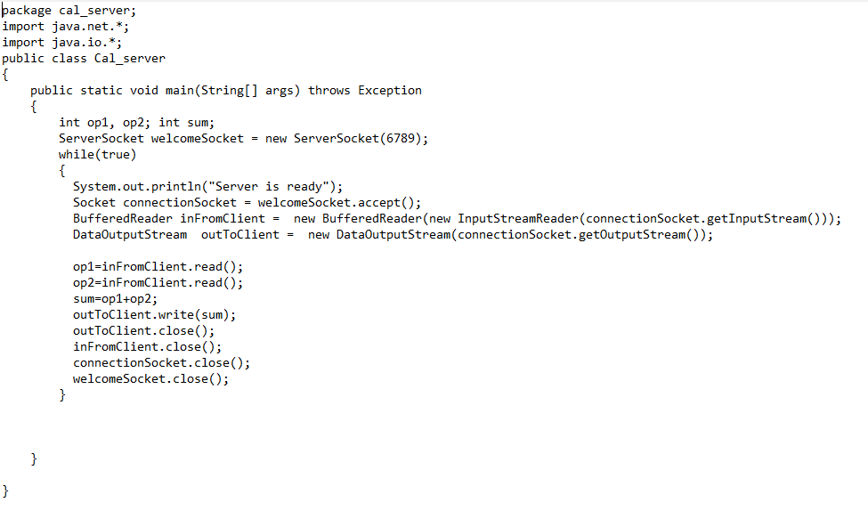

**Client:**

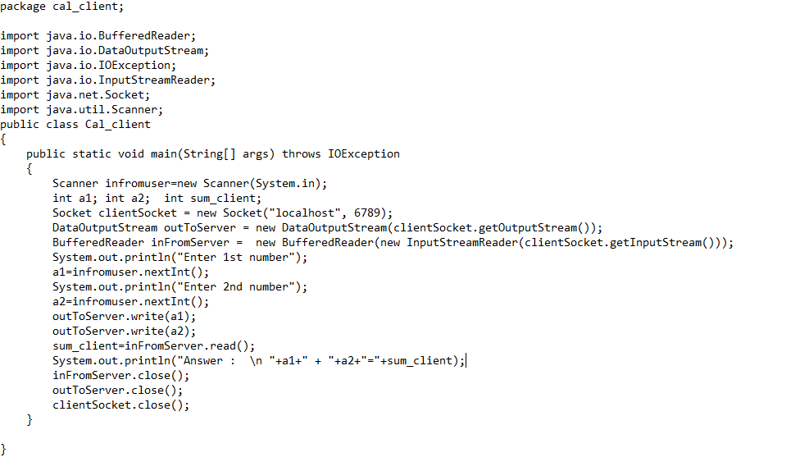

**Task:**

1. Implement the given calculator Application using socket programming,
2. Implement the chat application discussed in class.